PIN OAK MIDDLE SCHOOL
Fine Art Dept. 2016 T-shirt Order Form

Final Order

Student Name class period
Parent Name
Parent email
Parent phone
T-shirt back

Please indicate quantity
Syle Size: | AS | AM | AL | AXL | Cost
Short sleeve $15
Long sleeve $20
Pullover Hoodie $25
Total Amount Due:

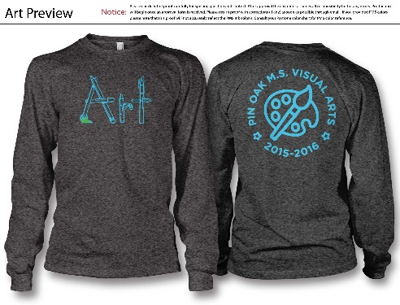 $20.00______
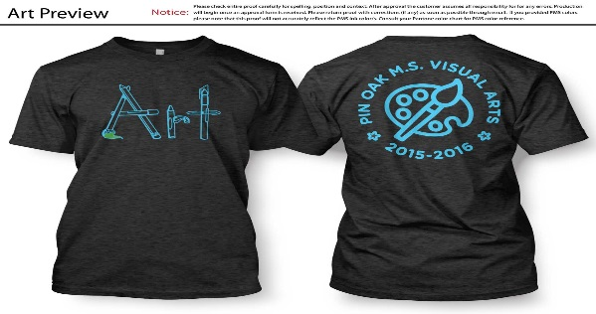$15.00______

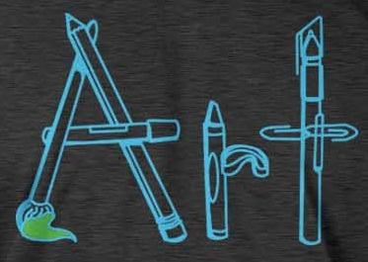
T-shirt front designed by Brianna Edwards

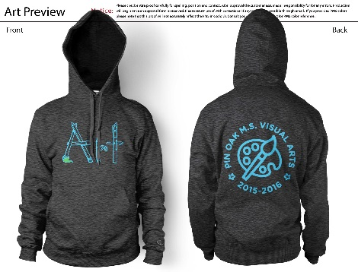$25.00_______

